Module-11
Electromagnetism:
Electromagnetism is a branch of physics involving the study of the electromagnetic force, a type of physical interaction that occurs between electrically charged particles. The electromagnetic force is carried by electromagnetic fields composed of electric fields and magnetic fields, and it is responsible for electromagnetic radiation such as light. It is one of the four fundamental interactions (commonly called forces) in nature, together with the strong interaction, the weak interaction, and gravitation.^{[1]} At high energy the weak force and electromagnetic force are unified as a single electroweak force.
Electromagnetic phenomena are defined in terms of the electromagnetic force, sometimes called the Lorentz force, which includes both electricity and magnetism as different manifestations of the same phenomenon. The electromagnetic force plays a major role in determining the internal properties of most objects encountered in daily life. The electromagnetic attraction between atomic nuclei and their orbital electrons holds atoms together. Electromagnetic forces are responsible for the chemical bonds between atoms which create molecules, and intermolecular forces. The electromagnetic force governs all chemical processes, which arise from interactions between the electrons of neighboring atoms.
There are numerous mathematical descriptions of the electromagnetic field. In classical electrodynamics, electric fields are described as electric potential and electric current. In Faraday's law, magnetic fields are associated with electromagnetic induction and magnetism, and Maxwell's equations describe how electric and magnetic fields are generated and altered by each other and by charges and currents.

Force acting on a current carrying conductor:
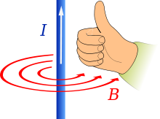
Fig.1 Force acting on a current carrying conductor

Prediction of direction of flux density (B), given that the current I flows in the direction of the thumb.
When electrons, or any charged particles, flow in the same direction (for example, as an electric current in an electrical conductor, such as a metal wire) they generate a cylindrical magnetic field that wraps round the conductor (as discovered by Hans Christian Ørsted).
The direction of the induced magnetic field is sometimes remembered by Maxwell's corkscrew rule. That is, if the conventional current is flowing away from the viewer, the magnetic field runs clockwise round the conductor, in the same direction that a corkscrew would have to turn in order to move away from the viewer. The direction of the induced magnetic field is also sometimes remembered by the right-hand grip rule, as depicted in the illustration, with the thumb showing the direction of the conventional current, and the fingers showing the direction of the magnetic field. The existence of this magnetic field can be confirmed by placing magnetic compasses at various points round the periphery of an electrical conductor that is carrying a relatively large electric current.
The thumb shows the direction of motion and the index finger shows the field lines and the middle finger shows the direction of induced current.
If an external magnetic field is applied horizontally, so that it crosses the flow of electrons (in the wire conductor, or in the electron beam), the two magnetic fields will interact. Michael Faraday introduced a visual analogy for this, in the form of imaginary magnetic lines of force: those in the conductor form concentric circles round the conductor; those in the externally applied magnetic field run in parallel lines. If those on one side of the conductor are running (from the north to south magnetic pole) in the opposite direction to those surrounding the conductor, they will be deflected so that they pass on the other side the conductor (because magnetic lines of force cannot cross or run contrary to each other). Consequently, there will be a large number of magnetic field lines in a small space on that side of the conductor, and a dearth of them on the original side of the conductor. Since the magnetic field lines of force are no longer straight lines, but curved to run around the electrical conductor, they are under tension (like stretched elastic bands), with energy bound up in the magnetic field. Since this energetic field is now mostly unopposed, its build-up or expulsion in one direction creates — in a manner analogous to Newton's Third Law of Motion — a force in the opposite direction. Since there is only one moveable object in this system (the electrical conductor) for this force to work upon, the net effect is a physical force working to expel the electrical conductor out of the externally applied magnetic field in the direction opposite to that which the magnetic flux is being redirected to — in this case (motors), if the conductor is carrying conventional current upwards, and the external magnetic field is moving away from the viewer, the physical force will work to push the conductor to the left.
Fleming's left-hand rule:
When current flows through a conducting wire, and an external magnetic field is applied across that flow, the conducting wire experiences a force perpendicular both to that field and to the direction of the current flow (i.e they are mutually perpendicular). A left hand can be held, as shown in the illustration, so as to represent three mutually orthogonal axes on the thumb, fore finger and middle finger.
Faraday's law of induction:
Faraday's law of induction (briefly, Faraday's law) is a basic law of electromagnetism predicting how a magnetic field will interact with an electric circuit to produce an electromotive force (EMF)—a phenomenon known as electromagnetic induction. It is the fundamental operating principle of transformers, inductors, and many types of electrical motors, generators and solenoids.
The Maxwell–Faraday equation (listed as one of Maxwell's equations) describes the fact that a spatially varying (and also possibly time-varying, depending on how a magnetic field varies in time) electric field always accompanies a time-varying magnetic field, while Faraday's law states that there is EMF (electromotive force, defined as electromagnetic work done on a unit charge when it has traveled one round of a conductive loop) on the conductive loop when the magnetic flux through the surface enclosed by the loop varies in time.
Faraday's law had been discovered and one aspect of it (transformer EMF) was formulated as the Maxwell–Faraday equation later. The equation of Faraday's law can be derived by the Maxwell–Faraday equation (describing transformer EMF) and the Lorentz force (describing motional EMF). The integral form of the Maxwell–Faraday equation describes only the transformer EMF, while the equation of Faraday's law describes both the transformer EMF and the motional EMF
Lenz's law:
Lenz's law, named after the physicist Emil Lenz (pronounced /ˈlɛnts/) who formulated it in 1834,^{[1]} states that the direction of the current induced in a conductor by a changing magnetic field is such that the magnetic field created by the induced current opposes the initial changing magnetic field.
Fleming's right hand rule:
Fleming's right hand rule states to hold the forefinger, middle finger and thumb of right hand mutually perpendicular to each other so that the forefinger points in the direction of external magnetic field and thumb points in the direction of motion of conductor.

Fleming’s left-hand rule gives the direction of magnetic force acting on a conductor whereas Fleming’s right-hand rule is used to find the direction of induced current.Fleming's left-hand rule is used to find the direction of magnetic force acting in an electric motors while Fleming's right-hand rule is used to find the direction of induced current in an electric generators.

An electric current and magnet field exist in an electric motor, and they lead to the force that creates the motion , and so the left hand rule is used which gives the direction of magnetic force acting. In an electric generator, the motion (due to force) and magnetic field exist and they lead to the production of an electric current , and so the right hand rule is used which helps us to find the direction of induced current.

Comparision between Fleming’s right-hand rule and Fleming’s left-hand rule:

Fleming’s right-hand rule :

According to this rule, “Stretch the thumb, forefinger and middle finger of the right hand such that they are mutually perpendicular to each other. If the forefinger points indicates the direction of the magnetic field and the thumb indicates the direction of motion of the conductor, then the middle finger will indicate the direction of induced current in the conductor”.

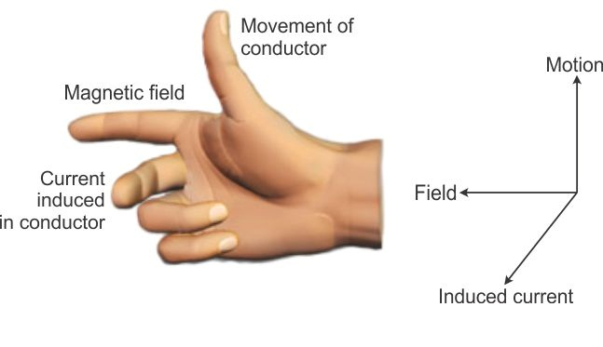

Fig.2 Fleming’s right-hand rule

Fleming’s left-hand rule :

According to this rule, “Stretch the thumb, forefinger and middle finger of the left hand such that they are mutually perpendicular to each other. If the forefinger points in the direction of magnetic field and the middle finger indicates the direction of the current, then the thumb will indicate the direction of motion or the force on the conductor”.

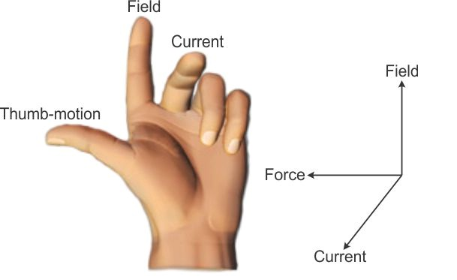

Fig.2 Fleming’s left-hand rule

References:
1. “Text book of Physics-I & II” by K.N. Barik, N. Barik and L. K. Das, Kalyani Publisher,2008.
2. sites.google.com
3. en.wikipedia.org
4. www.ukessays.com

Question Bank
1. What do you mean by Electromagnetic induction ?
2. State and explain Lenz’s law in relation with Electromagnetic Induction?
3. State Faraday’s Law of EMI.
4. Depict/Draw diagrams showing Left hand and Right hand thumb rule showing directions of quantities in EMI.
5. State and explain Fleming’s left hand rule.
6. State and explain Fleming’s right hand rule.

